The Impact of Data Segmentation Parameters on Performance in ECG-Based Identify Recognition Systems

Mehmet Bel*, Yakup Kutlu, Handan Gürsoy-Demir
¹ Department of Computer Engineering, Iskenderun Technical University, Turkey
ORCID: 0009-0009-8186-1833, 0000-0002-9853-2878, 0000-0001-5486-454X
Emails: mbel.lee24@iste.edu.tr, yakup.kutlu@iste.edu.tr, handan.gursoy@iste.edu.tr
*Corresponding author.

Abstract⎯ This study focuses on the segment duration required for identity recognition systems using electrocardiogram (ECG) signals, which are widely employed in disease diagnostics. Signals from the ECG-ID dataset were preprocessed and evaluated without detecting any critical points. The signals were segmented based on different parameters and fed into a Convolutional Neural Network (CNN) model, with results analyzed accordingly. The findings indicate that successful identity recognition can be achieved even with short segment durations. This highlights significant potential for developing more efficient and faster solutions in biometric security and identity verification systems.
Keywords⎯ Electrocardiogram, segment duration, biometric security, identity verification

- INTRODUCTION
With the increasing population and advancing technology, identity security has inevitably become a significant problem. Throughout history, various security measures have been adopted to address this issue. Initially, cryptographic methods such as passwords were used, but these systems were found to provide insufficient security. In response, the use of biometric systems began. What makes these systems more secure than other methods is their uniqueness to individuals and their resistance to imitation. Today, biometric systems, which we encounter in many areas, have become an integral part of our lives, replacing older security systems. There are multiple options available for biometric systems, with fingerprint, iris, and facial recognition systems being the most common [1]. Electrocardiogram (ECG) signals are also among the distinguishing features of individuals.
An ECG measures the electrical activity of the human heart. An ECG signal reflects the electrical representation of movements such as contraction and relaxation occurring during a heartbeat. A heartbeat consists of P, Q, R, S, and T points. Here, the P wave represents the contraction of the atria, the QRS wave corresponds to the contraction of the ventricles, and the T wave represents repolarization [2]. Correct detection of these points is crucial in research.
Initially significant for diagnosing diseases, ECG has been identified as a potential tool for identity verification. In a 2001 study, Biel and colleagues demonstrated that ECG signals, like other biometric features, are unique to individuals and can be used for identity recognition [3]. These signals are unique due to variations in certain characteristics from person to person.
The most significant advantage of ECG-based biometric security systems compared to other systems is that they are directly obtained from a living body, eliminating the possibility of imitation. Additionally, accurate identification of heart rhythm requires the individual to be in a relaxed state. Since the rhythm changes under threat, identification may fail, preventing validation. This feature enhances the security level of ECG-based systems even further.
- RELATED WORKS
Studies on identity recognition using ECG can be broadly divided into two main approaches. Most studies in the literature focus on identifying critical points in the signal, such as the R-peak, to perform the necessary processes. This method can achieve high accuracy due to its focus on specific points; however, its performance may decline in large datasets or noisy environments. In the other approach, critical points are not identified. Instead, this method analyzes the signal's overall features without focusing on specific points, potentially achieving higher accuracy [4].
The use of ECG in biometric systems was first introduced in 2001 by Biel and colleagues. In this pioneering study, 30 features were extracted from the signal using various critical points [3]. In 2014, Wu J. and Zhang Y. conducted a study where R-peaks were identified and used as the center of segments. Segment sizes were adjusted to include 40 points on either side of the R-point. Using artificial neural networks, this study achieved an accuracy rate of up to 99.7% [5]. In 2017, Hejazi M. and colleagues cleaned the signal from noise and divided it into 5-second windows [6]. In 2018, Bajare S. and Ingale D. segmented ECG signals into 2, 6, and 8-second intervals to investigate which segment length yielded the best results. After segmentation, R-peaks were identified, and frames were created. Using a 1D-CNN model, the best score was obtained with 8-second segments, achieving an accuracy of 96.93% [7]. In another 2018 study, Liu F. and colleagues segmented the signal to include 150 points before and 300 points after the R-peak. Using a GRNN classifier, the performance reached 97.7% [8]. In 2020, Hakan Gürkan and Ayça Hanilçi preprocessed the signals, determined QRS complexes, and divided them into 256-sample windows. A CNN model was employed, achieving 98.08% accuracy [9]. In 2020, Elshahed M. segmented the signal into R-R cycles of 200 points after identifying R-peaks. Euclidean calculations yielded an accuracy of 94.4% [10]. In another 2020 study by Ibrahim A. and colleagues, 10 R-R cycles of 200 points were configured for each individual. Using artificial neural networks, a performance of 98.41% was achieved [11]. Nuno Bento and colleagues conducted a study in 2020 where ECG signals were divided into 4-second segments. These signals were converted into spectrograms and processed using a CNN model, reaching an accuracy of 96.88% [12]. In 2021, Sinem H. and Yassine B.A. first identified R-points for segmentation and tested methods involving segments containing either one or two R-points. Using an SVM model, the highest accuracy for a single R-point was 99.4%, while a segment with two R-points achieved 100% accuracy [13].

- MATERIALS and METHODS
A. Dataset
In this study, the ECG-ID dataset from the PhysioNet database was used [14]. This dataset contains ECG signals from 90 individuals (44 males and 46 females), each consisting of 20-second recordings. The signals have a frequency of 500 Hz, and for some individuals, multiple recordings were collected at different times.
B. Preprocessing
To eliminate noise and interference, a band-pass filter with a frequency range of 0.5 Hz to 50 Hz was applied to the ECG signals. Subsequently, the filtered signals were normalized to enable comparison between signals from different individuals. This process ensured that the signals were transformed into a form suitable for analysis and modeling.
Subsequently, the signals were segmented based on specific parameters and different time durations. The segmentation process was carried out by considering the effects of parameters such as window length and overlap ratio. The signals were divided into segments of 0.25, 0.5, 1, 2, 3, 4, and 5 seconds, and it was observed which time duration provided sufficient accuracy.
C. Overlap
During the processing of ECG signals, a specific window size is set during the segmentation phase, and this window is shifted to divide the signal into segments. Overlap refers to how much the window overlaps with the previous ones. Higher overlap values cause more overlap, which increases the number of segments obtained, thus multiplying the amount of data.
In our study, overlap not only increased the amount of data but also enabled segments to be obtained from various starting points of the signal, as no critical point detection was applied. In this way, data for each variation was generated, allowing the model to better learn the signal.
D. CNN (Convolutional Neural Network)
CNN (Convolutional Neural Network) is a deep learning model widely used in image and signal processing applications. This model uses convolutional layers to learn local relationships in the data, automatically extracting important features.
The CNN model used in this study was designed to classify ECG signals. The model learns the features of the signals through convolutional layers, and then uses fully connected layers for classification. To process and classify the signals, the model is supported by techniques such as convolutional layers, dropout, and batch normalization. As a result, classification is performed on each segment of the signals using the softmax activation function.
- RESULTS
The effect of segmentation parameters in ECG-based identity recognition systems plays a critical role in the accuracy and efficiency of the system. In this study, ECG signals processed through preprocessing stages were fed into a CNN model, and the impact of segmentation parameters on accuracy was analyzed through the obtained outputs. Specifically, the study aimed to determine the optimal segment duration for accurate identity recognition.
For each segment duration, the models were run 5-10 times, and the average accuracy values were calculated. Based on these accuracy rates, the sufficient segment duration for identity recognition was sought.
The results are presented in the graph shown in Figure 1. Low accuracy rates were observed for segment durations below 1 second, while a significant improvement in accuracy was noted as the segment duration increased to 1 second or more. However, a decline in accuracy was observed for the 5-second segment duration.
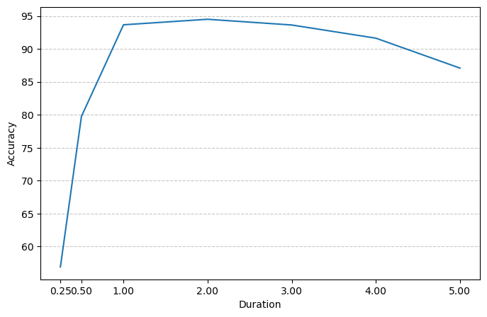Figure 1: Accuracy Based on Segment Durations
Additionally, the impact of different overlap ratios on accuracy was observed. The results for the various overlap values tested in the study are presented in the graph shown in Figure 2.
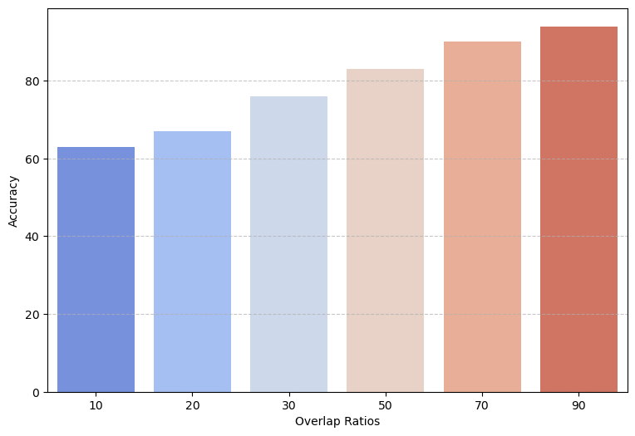Figure 2: Accuracy Result for Different Overlap Ratios
- CONCLUSION
The results obtained from the comparison of segmentation duration and performance clearly indicate that a minimum segment duration of 1 second is required to achieve sufficient accuracy in ECG-based identity recognition systems. Accuracy significantly drops for durations shorter than 1 second, suggesting that shorter segmentation durations are insufficient for the model to learn the data effectively. On the other hand, a decline in performance is observed when the segment duration exceeds 4 seconds. This indicates that increasing the segment length beyond a certain point may negatively impact the model's performance due to insufficient data.
In conclusion, this study aims to determine the necessary segment duration to achieve sufficient accuracy in ECG-based identity recognition systems. It has been observed that segment durations ranging from 1 to 4 seconds can achieve adequate accuracy. These findings highlight the importance of carefully selecting the segmentation duration to enhance system accuracy. This study will contribute to future research by improving model performance through the identification of the optimal segmentation duration.

REFERENCES
- Unar, J. A., Seng, W. C., & Abbasi, A. (2014). A review of biometric technology along with trends and prospects. Pattern recognition, 47(8), 2673-2688.
- Ingale, M., Cordeiro, R., Thentu, S., Park, Y., & Karimian, N. (2020). Ecg biometric authentication: A comparative analysis. IEEE Access, 8, 117853-117866.
- Biel, L., Pettersson, O., Philipson, L., & Wide, P. (2001). ECG analysis: a new approach in human identification. IEEE transactions on instrumentation and measurement, 50(3), 808-812.
- Hassan, Z., Gilani, S. O., & Jamil, M. (2016). Review of fiducial and non-fiducial techniques of feature extraction in ECG based biometric systems. Indian J. Sci. Technol, 9(21), 850-855.
- Wu, J. J., & Zhang, Y. (2014, December). ECG identification based on neural networks. In 2014 11th International Computer Conference on Wavelet Actiev Media Technology and Information Processing (ICCWAMTIP) (pp. 92-96). IEEE.
- Hejazi, M., Al-Haddad, S. A. R., Hashim, S. J., Aziz, A. F. A., & Singh, Y. P. (2017, September). Non-fiducial based ECG biometric authentication using one-class support vector machine. In 2017 Signal Processing: Algorithms, Architectures, Arrangements, and Applications (SPA) (pp. 190-194). IEEE.
- Bajare, S. R., & Ingale, V. V. (2019, July). ECG based biometric for human identification using convolutional neural network. In 2019 10th International Conference on Computing, Communication and Networking Technologies (ICCCNT) (pp. 1-7). IEEE.
- Liu, F., Si, Y., Luo, T., Wang, D., Liu, Q., & Li, L. (2018, December). The ECG identification based on GRNN. In 2018 IEEE International Conference on Communication Systems (ICCS) (pp. 418-422). IEEE.
- Gurkan, H., & Hanilci, A. (2020). ECG based biometric identification method using QRS images and convolutional neural network. Pamukkale University Journal of Engineering Sciences, 26(2), 318-327.
- Elshahed, M. A. (2020). Personal identity verification based ECG biometric using non-fiducial features. International Journal of Electrical and Computer Engineering, 10(3), 3007.
- Ibrahim, A. E., Abdel-Mageid, S., Nada, N., & Elshahed, M. A. (2020). ECG signals for human identification based on fiducial and non-fiducial approaches. International Journal of Advanced Computer Research, 10(47), 89-95.
- Bento, N., Belo, D., & Gamboa, H. (2020). ECG biometrics using spectrograms and deep neural networks. Int. J. Mach. Learn. Comput, 10(2), 259-264.
- Hamza, S., & Ayed, Y. B. (2022). Toward improving person identification using the ElectroCardioGram (ECG) signal based on non-fiducial features. Multimedia Tools and Applications, 81(13), 18543-18561.
- Goldberger, A., Amaral, L., Glass, L., Hausdorff, J., Ivanov, P. C., Mark, R., ... & Stanley, H. E. (2000). PhysioBank, PhysioToolkit, and PhysioNet: Components of a new research resource for complex physiologic signals. Circulation [Online]. 101 (23), pp. e215–e220. https://physionet.org/content/ecgiddb/1.0.0/

